Introduction

In the study of bonding we will consider several different types of chemical bond and some of the theories associated with them. The diagram below summarizes the types of bonding we will encounter.

To help distinguish the difference in strength of intra and inter bonds consider the process of boiling of water. When water boils the product is steam (gaseous water). The products are not hydrogen and oxygen. This is because the weak inter molecular forces are broken not the much stronger intra molecular forces.
- Intra Bonding

Ionic (the transfer of electrons between atoms to form ions that form giant ionic lattices)

Because of their stable electronic structures the noble gases are extremely unreactive elements undergoing relatively very few reactions and usually only under extreme conditions. Other atoms tend to seek these types of electronic structures, where the outer (valence) shell is full, in order to achieve stability.

Atoms have equal numbers of protons and electrons and consequently have no overall charge. When atoms lose or gain electrons, (in order to achieve full outer shells or a “noble gas structure” and stability), the proton electron numbers are unbalanced causing the particles to become charged. These charged particles are called IONS. The strong electrostatic forces between the charged particles are called ionic bonds. Since the electrostatic forces are large the bond is a strong one.

Since metals have a tendency to lose electrons to form positive ions and non-metals the opposite, the ionic bond is usually formed between metals & non-metals.

Sodium + Chlorine yield sodium chloride
x x
x x
x x
x

x x
x x
x x
x

Na + Cl [Na]⁺¹ + [ Cl ]⁻¹

NaCl

Covalent (the sharing of electrons between atoms to form discrete molecules)

In covalent bonding atoms once again want to achieve full outside shells, this time by joining together and sharing outer (valence) shell electrons. When they do so they form MOLECULES. One shared pair of electrons represents one covalent bond, two shared pairs form two covalent bonds, etc. These bonds usually occur between two atoms that are non-metals. Any electron pairs that occur in the outside shell of an atom but are not involved in bonding are called non-bonding electrons or lone pairs of electrons.

As the distance between the two nuclei become shorter, each atom’s nucleus starts to attract the other atom’s electron(s), thus lowering the potential energy of the system. The atoms continue to draw each other closer, and the system becomes progressively lower in energy. As attractions increase, so do repulsions between the nuclei and between the electron clouds. At some internuclear distance, the maximum attraction is achieved. Any shorter distance would increase the repulsions and cause the potential energy to rise.

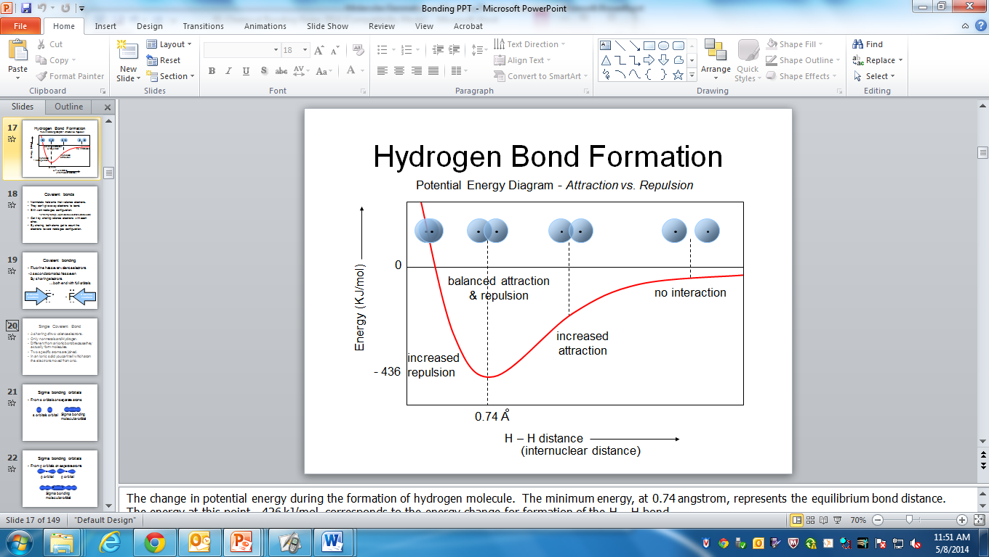

Potential energy is based on the position of an object.

Low potential energy = high stability.

Lewis structures

Lewis structures use dots to represent outer shell electrons in atoms when they form molecules. As discussed above when atoms form molecules they share electrons to achieve full outer shells. In the case of hydrogen this is 2 (duet rule), in the case of the second period non-metal elements this is 8 (octet rule). Some elements in the third period can have more than eight electrons in their outer shells (expanded octet rule).

To Draw Lewis Structures And VSEPR Molecules

- All atoms want to achieve an octet of electrons except for:
H, Li, (2 e⁻) Be, (4 e⁻) and B (6 e⁻)
{electron deficient compounds}
- Predict the arrangement of atoms within the molecule, using the following rules:
    - H is always an end (terminal) atom. It is connected to only one other atom.
    - The atom with the lowest electronegativity is the central atom.
- Having decided on the general arrangement of atoms, find the total number of valence electrons by adding up the group numbers of the elements.
    - For negative ions, add the ion charge to the sum of group numbers.
    - For positive ions, subtract the ion charge.
- The number of valence electron pairs to be used is half the total number of valence electrons.
- Place one pair of electrons (sigma bond) between each pair of bonded atoms.
- Place lone pairs about the terminal atoms (except H) to satisfy the octet rule. (There are some exceptions to this rule, EXPANDED OCTET.) If pairs are still left over at this point, assign them to the central atom.
- If the central atom is not yet surrounded by four electron pairs, convert one or more terminal atom lone pairs to pi bond pairs. In this way the pairs are still associated with the terminal atom, and also a part of the central atom.
    - Usually only C, N, O, and S are the only atoms that can form pi bonds.

H₂

H 1s¹
H H

Hx 1s¹

H x H Now each hydrogen has 2 e⁻ in outermost shell (like He)

H H
This is an example of one shared pair of electrons.

When atoms form covalent bonds there is an overlap of the atomic orbitals to form the molecule.

For example consider two hydrogen atoms forming H₂. Each hydrogen atom has one electron that occupies a spherical 1s orbital. On forming H₂ these 1s orbitals overlap to share a pair of electrons forming a molecule and a covalent bond.


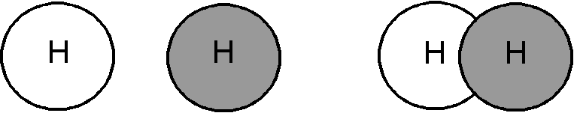
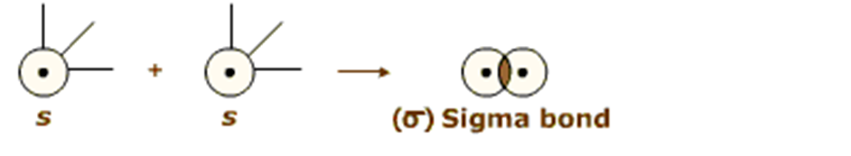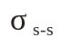
Cl₂

Cl 1s²2s²2p⁶3s²3p⁵

1s 2s 2p 3s 3p

x x
x x
x x
x

Cl 1s²2s²2p⁶3s²3p⁵

1 shared pair = single bond
x x
x x
x
x x

Cl Cl

Each has an octet.

Bonding pair (Shared Pair): electrons involved in bonding

Lone Pair (Unshared Pair): electrons not involved in bonding
(non-bonding electrons)
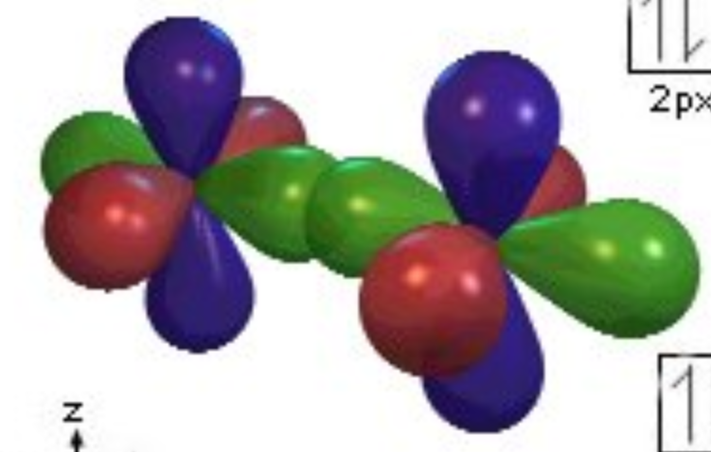
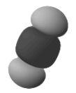
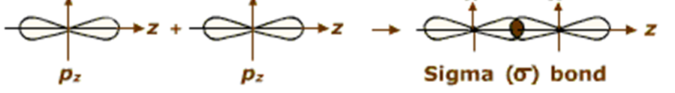

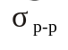
O₂:

O 1s²2s²2p⁴

x x
x x x
x

O O Each atom has an
1s 2s 2p
octet of electrons

x x
x x
x
x

O 1s²2s²2p⁴ O O Two shared pairs =
Double bond

When two pairs of electrons are shared a double bond results.
(one sigma bond, σ, and one pi bond, π)
Bond order = 2

Now consider two oxygen atoms forming O₂. Each oxygen atom has the electronic configuration [He] 2s²2p⁴.

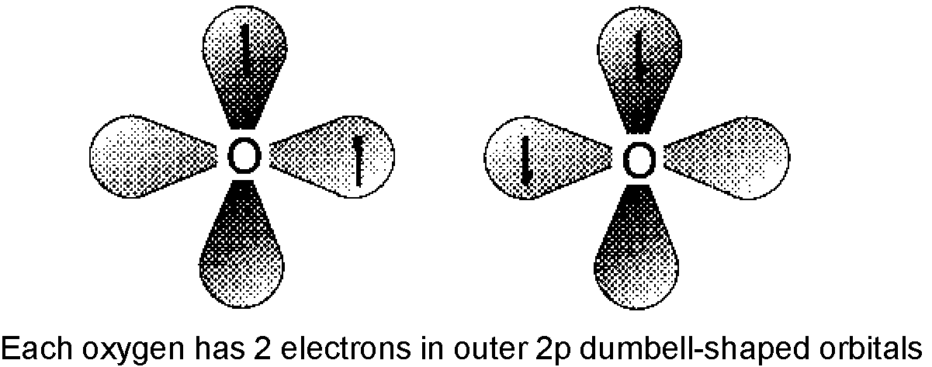
The 2, dumbbell shaped, 2p orbitals that are incomplete can take part in bonding and there is a simple end on end overlap that occurs. The electron cloud density is located along the axis of the bond and this is called a sigma (σ) covalent bond.
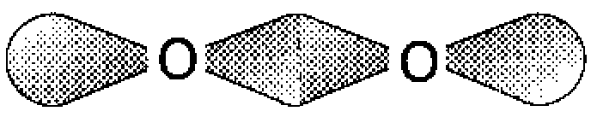

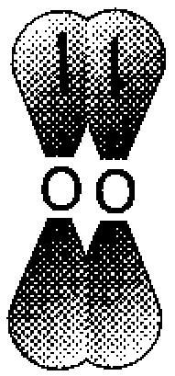
There is also scope for another type of bond that occurs from the sideways overlap of the other p orbitals. Here the electron cloud density is located above and below the axis of the bond this is called a pi (π) bond.

As a result the oxygen atoms form a double bond giving the familiar oxygen molecule, O=O or O₂.

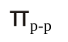
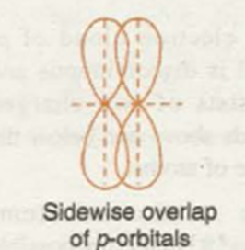
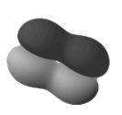
N₂:

N 1s²2s²2p³

x x x x
x

N N
1s 2s 2p

x x
x x
x
x

N 1s²2s²2p³ N N

Three shared pairs = Triple bond

When three pairs of electrons are shared a triple bond results.
(one sigma bond, σ, and two pi bonds, π)
Bond order = 3

Bond Length: distance between two nuclei of two bonded atoms.

Bond energy: a force that holds atoms together or a force that must be overcome to separate atoms.
(Related to bond order)

Triple bonds > Double bonds > Single bonds

Strongest Weakest
Shortest bonds Longest Bonds

Draw Lewis diagrams of
these molecules.
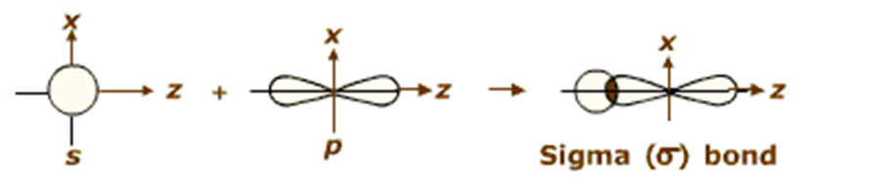
Hetero nuclear diatomic HCl, HF
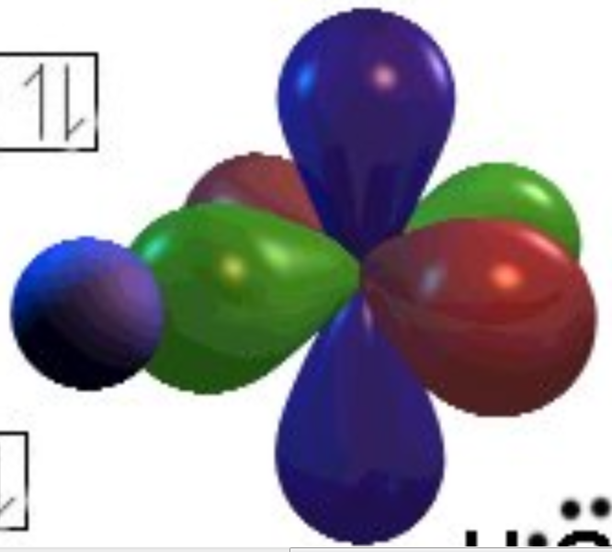
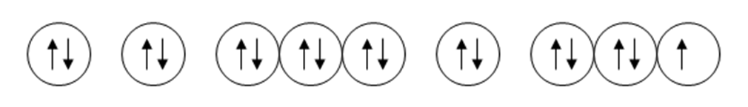

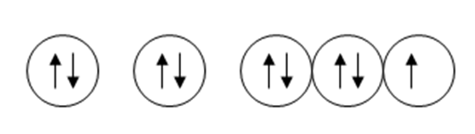
Hetero nuclear triatomic H₂O
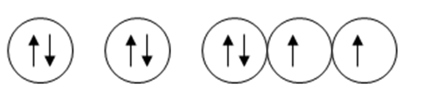
Hetero nuclear tetratomic NH₃

Hetero nuclear pentatomic CCl₄

Before we go any further we need to talk about VSEPR Theory and hybridization.

A primary role of studying chemistry is to learn how the macroscopic properties of matter are a consequence of its molecular structure.

The behavior of atoms is determined chiefly by their electron configurations (valence electrons.)

The behavior of molecules also depends on their structural characteristics.

To look at the structure of a molecule and to describe its shape we will use VSEPR Theory.

VALENCE
SHELL
ELECTRON
PAIR

REPULSION

VSEPR theory is based on the premise that electron clouds repel each other.

- Like charges repel (e⁻ have the same charge)
- Pauli Exclusion Principle (same spin are very repulsive)

THESE REPULSIONS DETERMINE THE ARRANGEMENT, WHICH IN TURN DETERMINES THE SHAPE OF THE MOLECULES.

The main rule we will use is:

ELECTRON PAIRS SPREAD AS FAR APART AS POSSIBLE
TO MINIMIZE REPULSIVE FORCES.

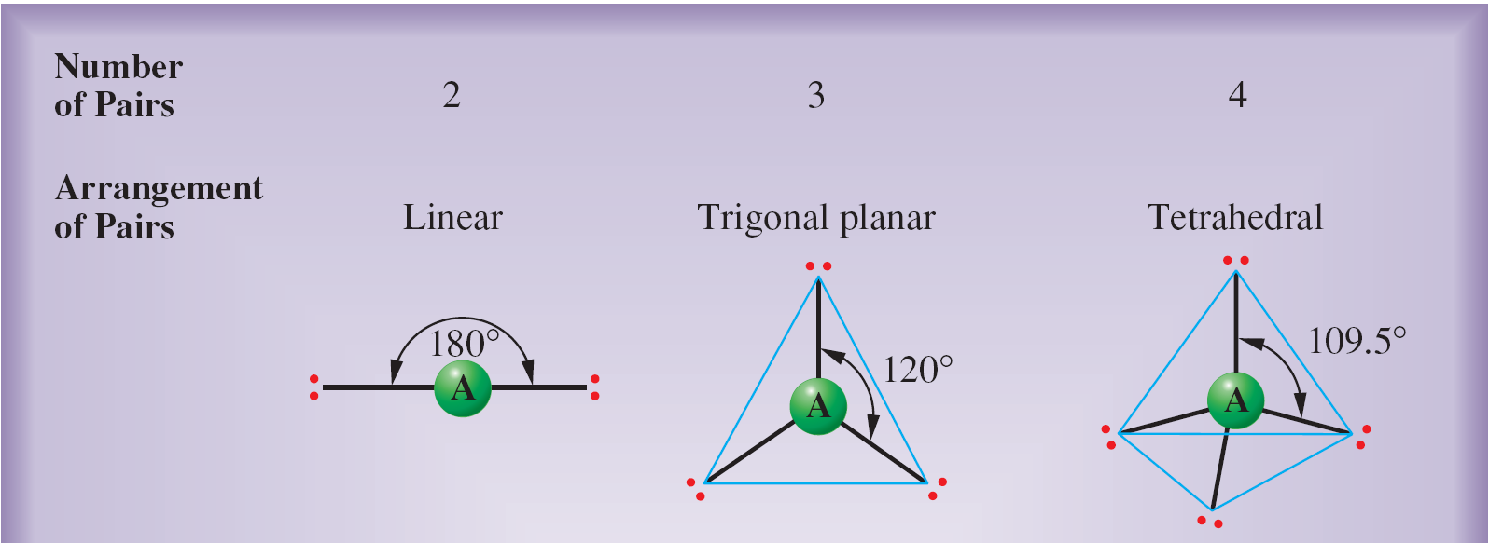
2 electron pairs: opposite sides of the nucleus = linear, 180°

3 electron pairs: trigonal planar, 120°
within the same plane
4 electron pairs: tetrahedral, furthest apart @ 109.5°,
not in the same plane

Unshared pairs on the central atom affect these bond angles.

Unshared pairs are huge electron clouds, thus the more unshared pairs the more the bond angles will be influenced.

Let’s talk a little about hybridization….
Hybridization is when atomic orbitals from the bonding atoms overlap and mix to form degenerate, molecular orbitals. Because these are hybrids, they are influenced by the atomic orbitals that compose them.

BeCl₂:

Be: has a valence configuration of 2s²

Since there are no unpaired electrons, we could immediately predict that Be does not form any bonds. However, in the gas phase Be does form the molecule BeCl₂!?!?!?!?!?!?!

How can we account for this? By unpairing the two valence shell electrons.

In order to do that, one of the electrons must be promoted (excited) to the next available subshell within the same valence shell.

2s 2p
Through experimentation, it is proven that each of the bonds formed are identical. This cannot happen with our present situation (E_{s} < E_{p}) {s<p<d<f}

So, we will hybridize those two orbitals to form degenerate molecular bonding orbitals.

“sp” 2p

When an s orbital and p orbital overlap and form a hybrid, the resulting 50% s and 50% p orbital is called an sp orbital. This orbital is more spherical than an atomic p orbital

nucleus

Cl Be Cl

LINEAR, 180°

Cl—Be—Cl

This is the Lewis and VSEPR structure
BF₃

B: 2s²2p¹

According to the above configuration, B can only form a single, sigma bond, yet according to the formula, we know that B forms three bonds with fluorine.

How can this be? Hybridization!!!!!!!!

Becomes
2s 2p

These hybrid orbitals have 33% s and 66% p character

F

Trigonal Planar
120°
B

F F

Lewis structure

VSEPR structure
CH₄:

C: 2s²2p²

2s 2p

This configuration indicates 2 bonds, however we know that C forms 4 bonds.

Becomes
2s 2p

Lewis structure

Tetrahedral, 109.5°

VSEPR structure

NH₃:

N: 2s²2p³

Even though the number of bonds that can be formed (3 in this case) is shown in both the orbital diagram and in the formula for ammonia, hybridization still occurs. Through a series of tests all three bonds are shown to be identical.

Becomes
2s 2p

There is a big difference in the structure of this molecule due to the lone pair in the first orbital. This shape is trigonal pyramidal, 107°, in nature.

Lewis structure

The lone pair repulses the three bonds
pushing them away.

Trigonal Pyramidal, 107°

VSEPR structure
H₂O:

O: 2s²2p⁴

Becomes
2s 2p

In the structure for water, there are 2 lone pairs. This makes the structure, angular or bent, 105°.

Lewis Structure

Bent, 104.5°

VSEPR Structure

PF₃ and PF₅:

P: 3s²3p³

Phosphorous can form compounds with either 3 or 5 bonds.

When it bonds with 3 other atoms, P will hybridize to sp³ with one lone pair, trigonal pyramidal, 107°.

PF₅ is very different.

In this case the central atom has an EXPANDED OCTET (5 bonding pairs, 10 e⁻).

Hybridization must occur with the promotion of an electron to the next highest sublevel within the same energy level, 3d.

Before hybridization:

3s 3p 3d

After hybridization:

Lewis Structure

F X

Trigonal One lone Pair
Bipyramidal F X

120° and 90°
P F M

F X
See-Saw
90° and 120°
F X

With two lone pairs With three lone pairs

T-shaped X X
Linear

M X M

X X

SF₆:

S: 3s²3p⁴

3s 3p 3d

This two bond arrangement will hybridize to a 6 bond configuration by promoting 2 e⁻ to the d sublevel.

Lewis
Structure
Octahedral
90° everywhere
F

F F

S

F F

F

One Lone Pair Two lone pairs

Square Pyramidal Square Planar

X

X X X X

M
M

X X X X

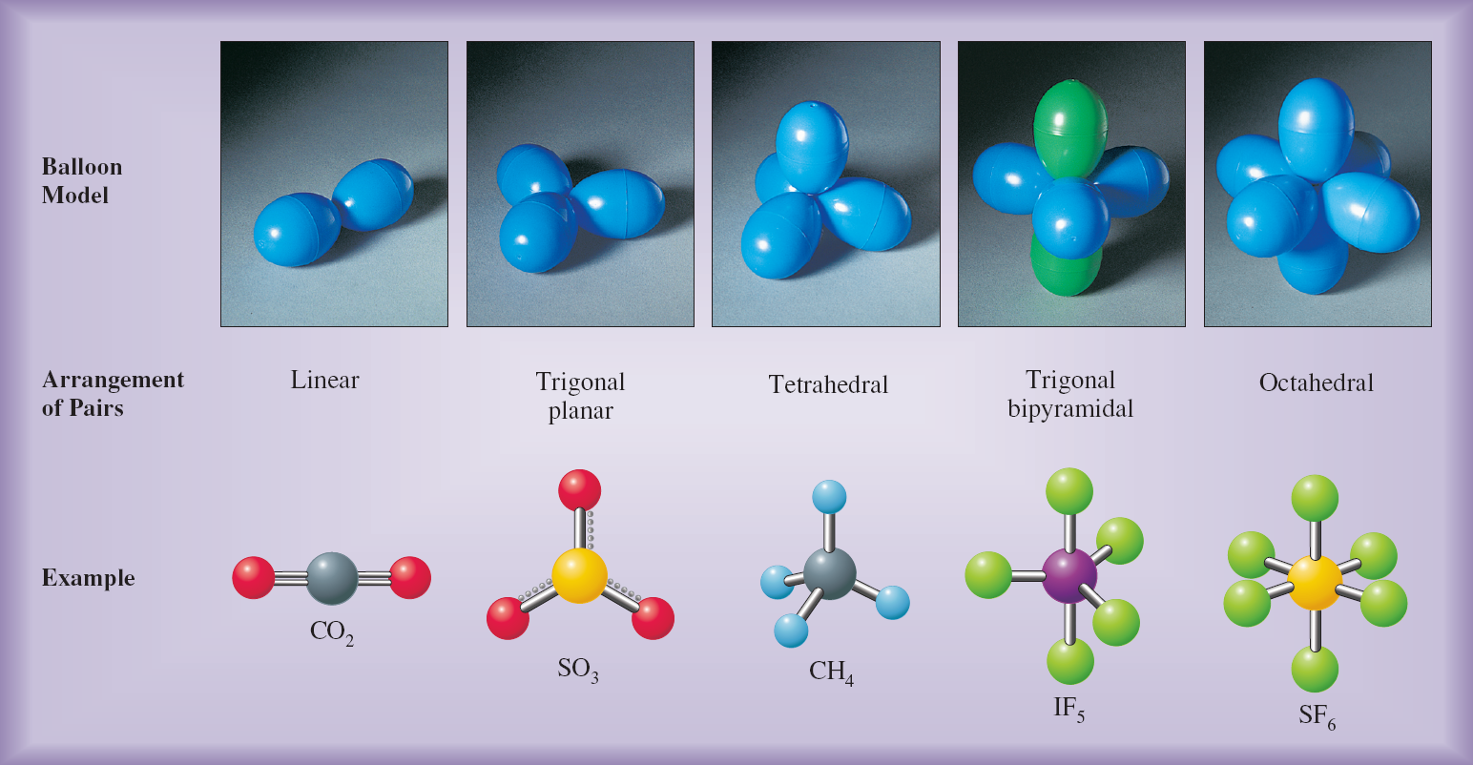

Number of pairs around central atom |  | Full description of the molecule
BONDING | NON-BONDING (LONE) | Example | Bond Angles in º | Arrangement of electron Pairs | Geometry of Atoms | 3D Shape | Type
2 | 0 | BeCl₂ | 180 | Linear | Linear | 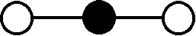 | AB₂
3 | 0 | BF₃ | 120 | Trigonal planar | Trigonal planar | 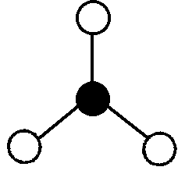 | AB₃
4 | 0 | CH₄ | 109.5 | Tetrahedral | Tetrahedral | 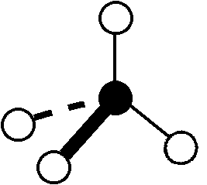 | AB₄
3 | 1 | NH₃ | 107.5 | Tetrahedral | Trigonal pyramidal | 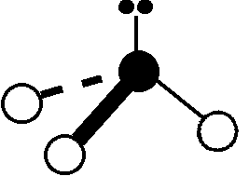 | AB₃E
2 | 2 | H₂O | 104.5 | Tetrahedral | Bent or V Shaped | 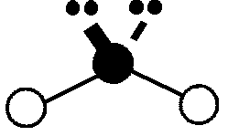 | AB₂E₂
5 | 0 | PCl₅ | 120 in plane. 90 perpendicular to plane | Trigonal bipyramidal | Trigonal bipyramidal | 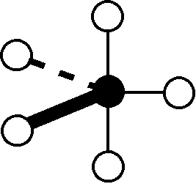 | AB₅
4 | 1 | SF₄ | 120 in plane. 90 perpendicular to plane | Trigonal bipyramidal | Seesaw | 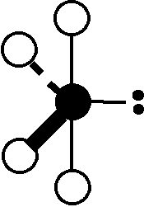 | AB₄E
3 | 2 | ClF₃ | Approx. 90 | Trigonal bipyramidal | T-Shaped | 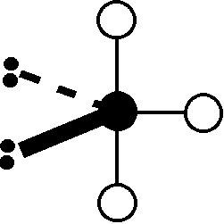 | AB₃E₂
2 | 3 | XeF₂ | 180 | Trigonal bipyramidal | Linear | 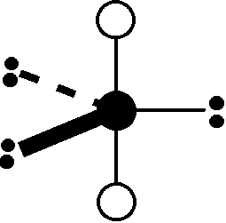 | AB₂E₃
6 | 0 | SF₆ | 90 | Octahedral | Octahedral | 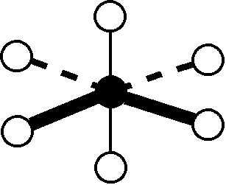 | AB₆
5 | 1 | BrF₅ | 90 | Octahedral | Square Pyramidal | 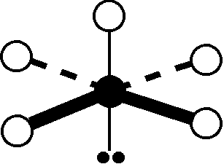 | AB₅E
4 | 2 | XeF₄ | 90 | Octahedral | Square planar | 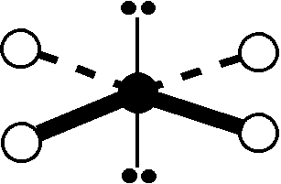 | AB₄E₂

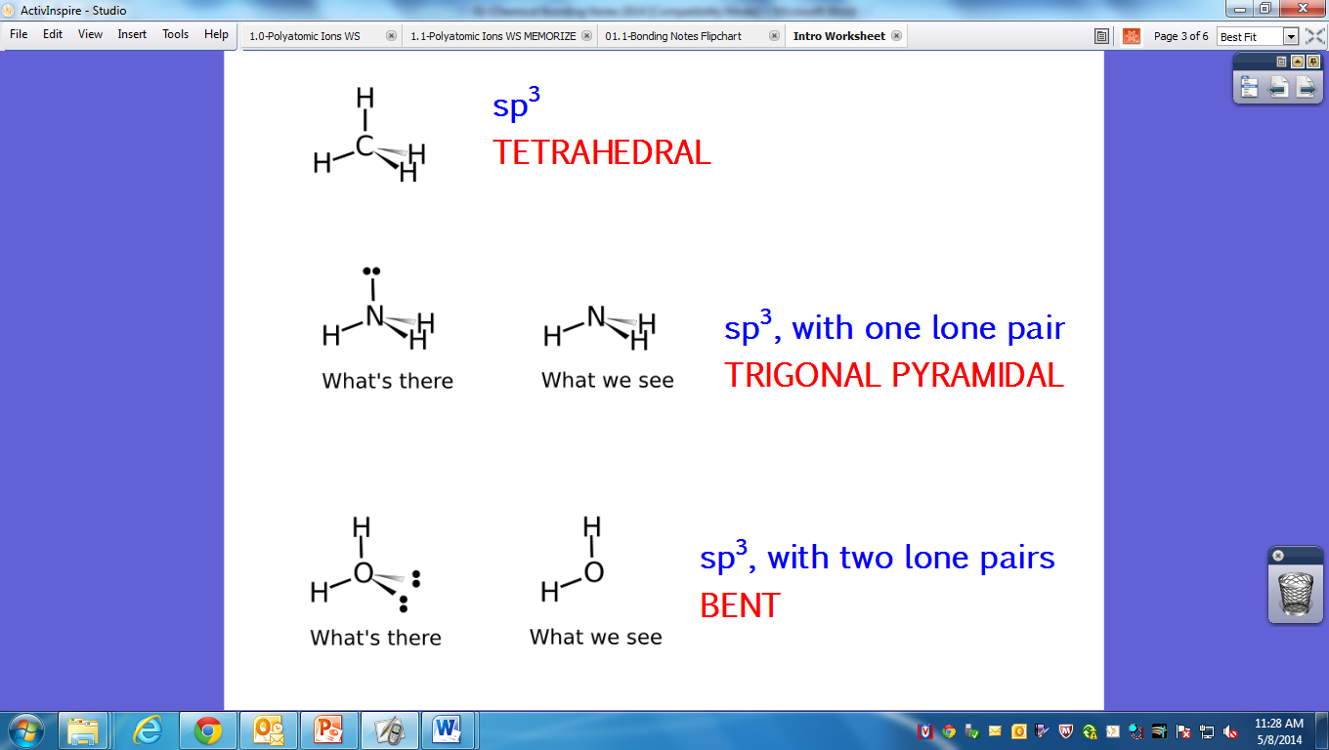

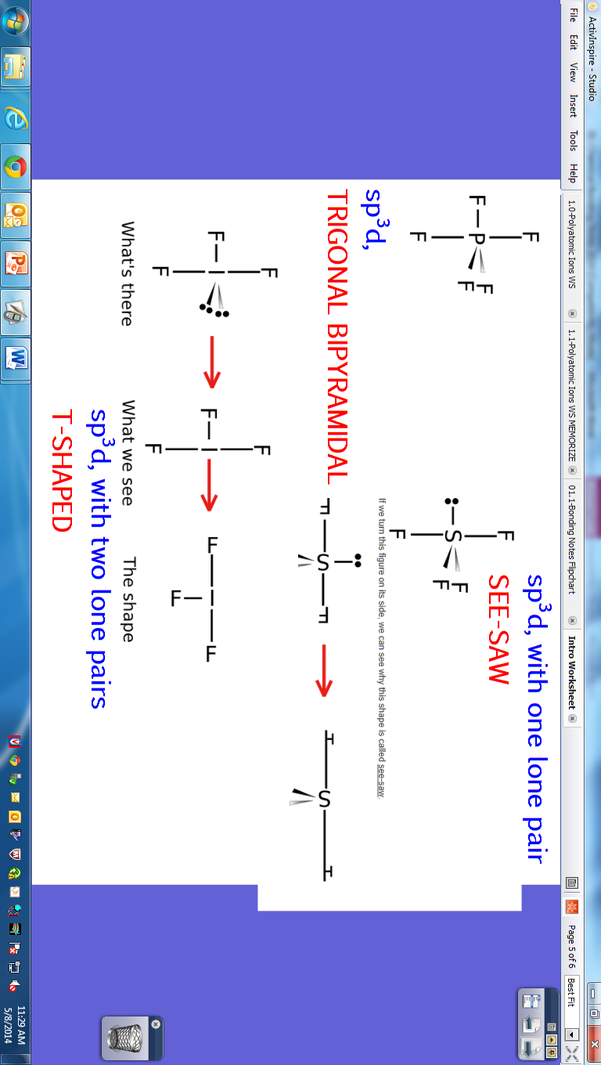
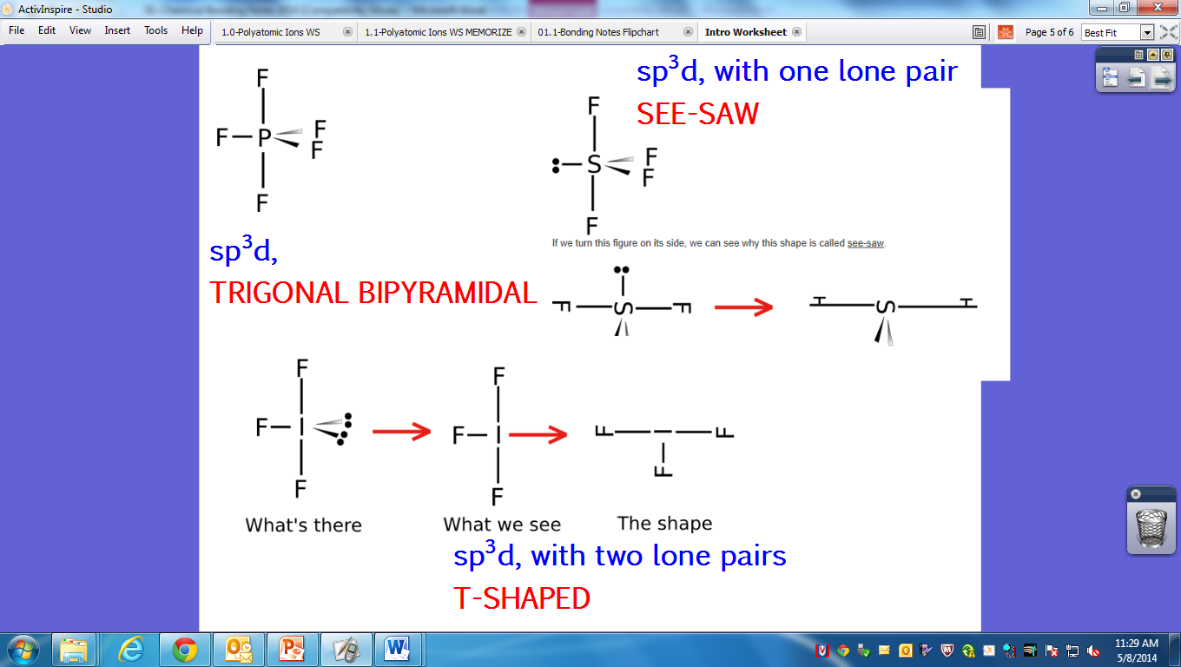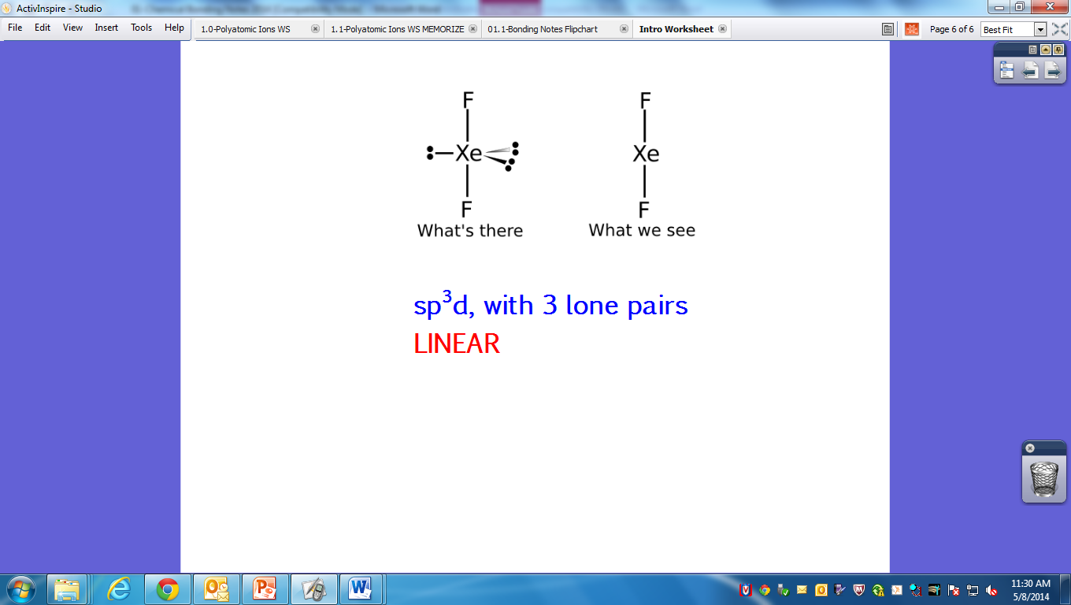

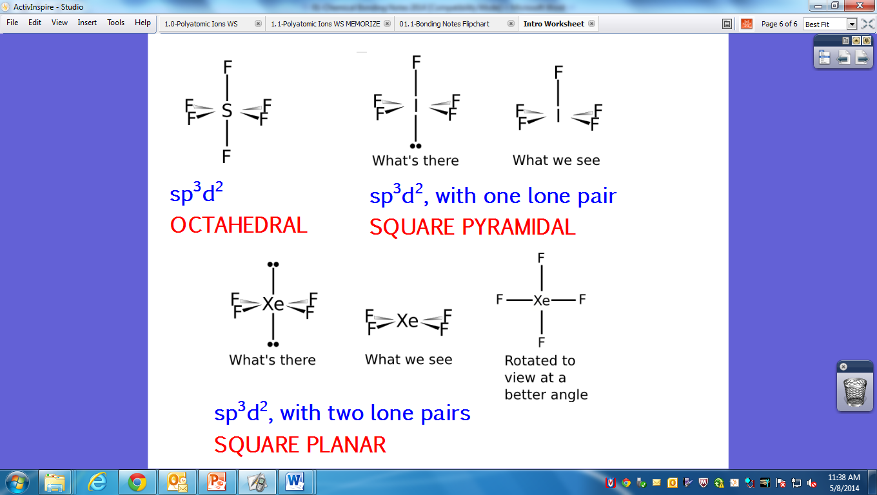
What if the molecule contains pi bonds (multiple bonds between atoms?

Hybridization = sp^{(3 – no. of pi bonds)}

Resonance structures and Formal charge

Occasionally when drawing a Lewis structure that involves multiple bonds it may be possible to draw a number of different, correct, Lewis structures. In such a case we call the various structures resonance structures. E.g. Carbon dioxide has three possible Lewis structures.

The formal charge of an atom within a Lewis structure can be used in two ways.

- To suggest where charge separation might most reasonably lay
- To help select the most plausible structure from a set of resonance structures
- The most stable structure is the one in which:
    - The atoms bear the smallest formal charges.
    - Any negative charges reside on the more electronegative atoms.

To calculate the formal charge on an atom within a Lewis structure, apply the following formula.

$$\begin{aligned}\left(\text{Formal Charge on an atom} | \right) \\ \end{aligned}$$

Using the Lewis structure for the carbonate ion (CO₃²⁻) as an example

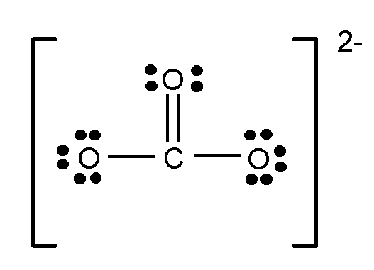

It is possible to determine the formal charges on the atoms and therefore the most likely separation of charge.
Carbon atom Formal charge = 4 – 0 – ½ (8) = 0
Oxygen atom in C=O Formal charge = 6 – 4 – ½ (4) = 0
Each oxygen atom in C-O Formal charge = 6 – 6 – ½ (2) = -1

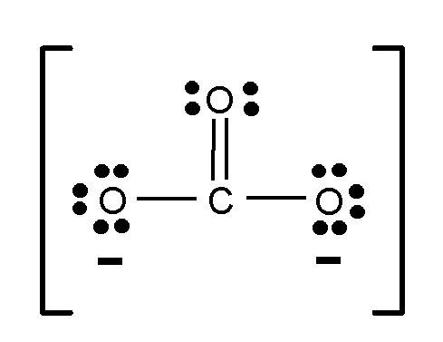

Using the two possible Lewis structures for CH₂O with formal charges added as an example it is possible to determine the most likely Lewis structure for the compound. In order to determine which structure is most likely keep the formal charges as low as possible and keep formal charges on the most electronegative atoms. Since the first structure has no formal charges it is considered to be the most plausible.

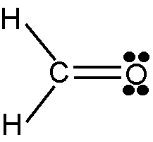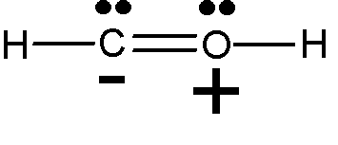

SCN⁻¹ (thiocyanate ion):

If there are more than one valid resonance structures, then the true structure is represented as an average or superposition of all the resonance structures.

SO₂

Dative or Co-ordinate Bonding (Electron deficient species)

Occasionally when drawing a Lewis structure you may encounter a molecule with a central atom that does not have a complete octet of electrons surrounding it. One such example is BF₃. In this molecule the boron atom has only six electrons surrounding it rather than the required eight.

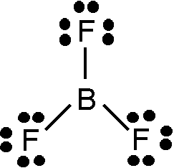
The boron atom is said to be electron deficient. It makes up the octet by forming bonds with other compounds that have non-bonding pairs of electrons, e.g. ammonia (NH₃).

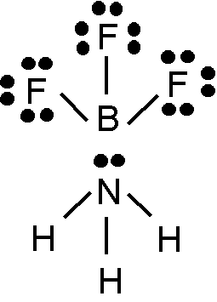

The new, shared pair (covalent bond) formed is made up by using both the electrons from one species (in this case the nitrogen atom in the ammonia molecule) rather than one from each species as in a normal covalent bond. This type of covalent bond is called a
dative or co-ordinate bond.
Electron clouds and the sliding scale of bonding type

An electron cloud diagram can be thought of as a probability map of where an electron may be found at any one time. In separate atoms this is very simple.

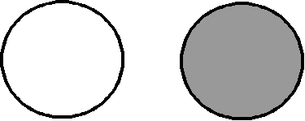

When a chemical bond forms there is a redistribution of the outer electron clouds.

Electrons may be completely transferred (100% ionic bonding)

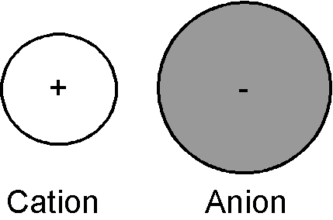

or completely shared (100% covalent bonding)



In the simplest terms it is possible to think of compounds being either 100% ionic or 100% covalent but actually it is necessary to consider these two situations being at the extremities of a sliding scale. In fact most bonds are intermediate between the two, with a largely covalent substance actually having a degree of ionic behavior, and visa-versa.

Ionic substance with some covalent character

If the cation is small and highly charged it will have the ability to distort the charge cloud around the anion thus;

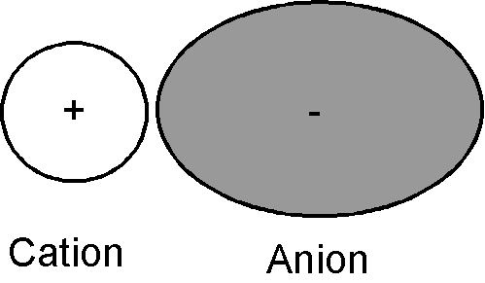

Comparing this diagram with the charge cloud representations of 100% ionic bonding and 100% covalent bonding it is possible to observe the ionic bond beginning to acquire some covalent character. Fajans rules help to assess the degree of distortion (POLARIZATION). Distortion will be at a maximum when;

1. The cation is small and highly charged, i.e. has a high charge density.
2. When the anion is large and highly charged, i.e. electrons are more loosely held.

Covalent substance with some ionic character

Electronegativity is the ability of an atom within a covalent bond to attract electrons to itself. When, in a covalent bond, one atom has a higher electronegativity than the other, the electrons are attracted toward that atom leading to a charge cloud distortion thus;
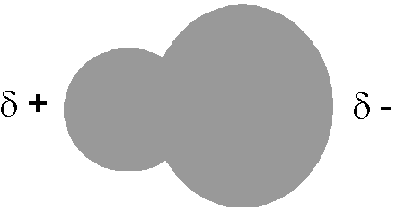

Comparing this diagram with the first two charge cloud representations, it is possible to observe the covalent bond beginning to acquire some ionic character.

It is possible to make predictions about the degree of ionic and covalent character in a compound. By considering differences in electronegativity and by using the table below, one can predict the % of covalent and ionic character present in a bond between two atoms.

It can be seen from the table that a difference of approximately 1.7 marks the boundary between predominately ionic or covalent character.

Polar: 1.7 > ΔEN > 0.4

Nonpolar: ΔEN < 0.4

In a nonpolar covalent bond there is an equal sharing of electrons between the bonding atoms due to their similar electronegativities.

In a polar covalent bond, there is a large enough difference in EN that the electrons are not shared equally and yet not a big enough difference that they are not transferred (ionic) between atoms.

The larger the ΔEN the more polar the resulting bond.

The properties of a compound that is made up of polar bonds versus one that only contains nonpolar can be dramatically different.

- Polar bonds and polar molecules

In order for a substance to be polar, opposite ends of the molecule must carry different charges (i.e. a dipole moment must exist) AND the dipoles that are present must NOT cancel out due to symmetry. The dipole moment can be indicated by an arrow that points toward the negative charge center with the tail of the arrow indicating the positive charge center, or by using δ+ and δ- to indicate small areas of positive and negative charge.

E.g. propanone and trichloromethane are both polar liquids that are attracted to a static electric charge. Like water, (which is also polar), opposite ends of the molecules carry different charges and there is no canceling of the dipoles.

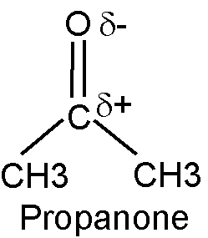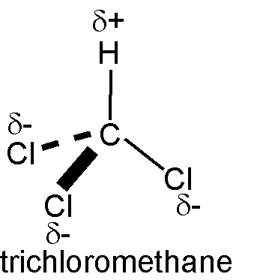

Consider hexane and carbon tetrachloride, neither are polar molecules but for different reasons.

1. Hexane (C₆H₁₄). Carbon and hydrogen have similar electronegativities and as a result the bonds are effectively non-polar.

2. Carbon tetrachloride (CCl₄). Has four polar C-Cl bonds but because of its symmetrical shape is non-polar overall. The partial positive charge is located at the center of the molecule and the partial negative charges equally spread around it, causing the dipoles to cancel.

Examples of other compounds that are non-polar as a result of symmetry and the cancellation of dipoles are CO₂ and BF₃.
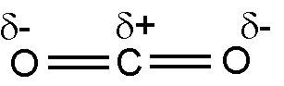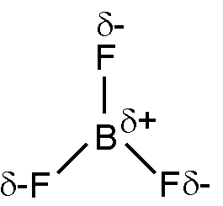

- Shapes of covalently bonded molecules and ions

The shapes of covalently bonded molecules and ions can be determined by considering the number of electron pairs around the central atom. The electron pairs repel one another and try to get as far apart as possible. This theory is called Valence Shell Electron Pair Repulsion theory or VSEPR. There are some standard shapes for specific numbers of electron pairs and some simple deviations from this theory when non-bonding pairs are present around the central atom.

A non-bonding pair will repel more strongly than a bonding pair. When comparing bond angles it can be seen that this has the effect of altering the bond angles and the shape of molecules that have a similar total number of electron pairs around the central atom.

HOW TO TELL IF A MOLECULE IS POLAR (DIPOLE) OR NONPOLAR?

- Does it contain polar bonds?
  - If yes, draw in the partial charges (δ⁺ and δ⁻) on each of that bonding atoms, assigning the more electronegative atom the δ⁻.
  - If no, then the molecule is NONPOLAR.
- Is there symmetry? “Can you draw the line?”

Does symmetry cancel the polar bonds?

  - Are there lone pairs on the central atom?
    - If yes, generally molecule is POLAR.
    - If no, continue to b.
  - Are all of the terminal atoms of the same element?
    - If yes, NONPOLAR.
    - If no, is there symmetry?
      - Yes, NONPOLAR.
      - No, POLAR.

Predicting shapes of molecules

1. Draw the Lewis structure for the molecule.
2. Count the electron pairs around the central atom and arrange them in a way that minimizes repulsion (i.e. keep them as far apart as possible).
3. Identify the correct shape, name and bond angles that correspond to the position of the atoms in the structure.

Draw Lewis structures clearly indicating the arrangement of outer electrons, the overall shape and the bond angles of the following species:

PCl₆⁻

ICl₃

BrF₅

SO₃²⁻

NH₄⁺

ICl₄⁻

SO₂
- Inter Bonding

Hydrogen Bonding

Hydrogen is an exceptional element in that when it forms a covalent bond its electron is held to one side of the nucleus leaving the other side relatively bare. Any approaching negatively charged group can get very close to the hydrogen nucleus and produce an unexpectedly large electrostatic attraction. These electrostatic attractions are exaggerated when H is bonded to a more electronegative element e.g. N, F or O. Such electrostatic attractions are called hydrogen bonds.

The occurrence of hydrogen bonds has two important consequences.

(i) It gives substances containing them anomalously high boiling points.
(ii) Substances containing them tend to be more viscous.

Both are explained by the increased attraction between molecules caused by hydrogen bonding making it more difficult to separate them. For example, in water. Black circles represent oxygen atoms and white circles represent hydrogen atoms.

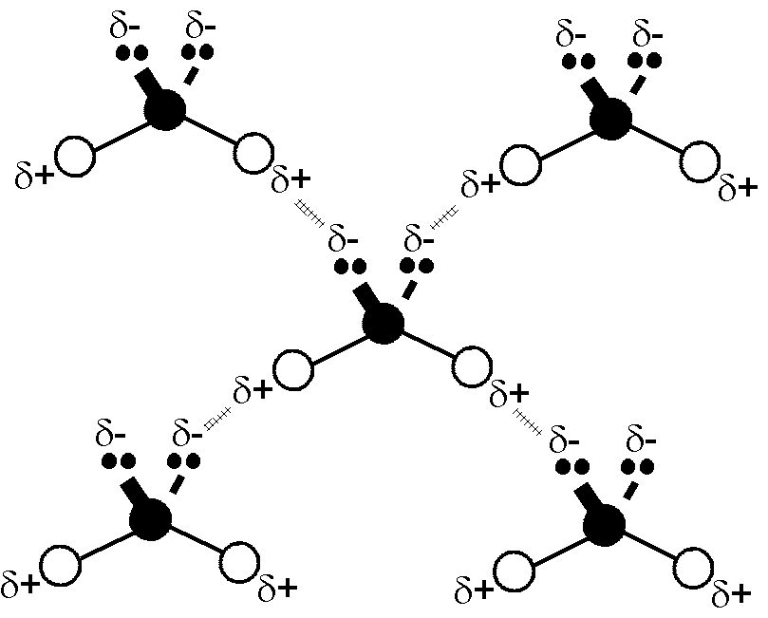

van der Waals Forces

van der Waals forces fall into two separate categories.

Dipole-Dipole Interactions

When molecules that have permanent dipoles come together, they will arrange themselves so that the negative and the positive ends of the molecules attract one another.

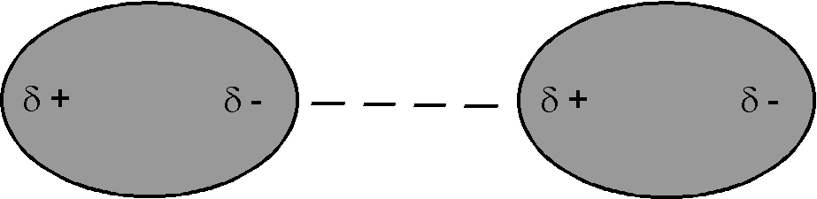

The attractions are called dipole-dipole interactions. The molecules eventually align in order to find the best compromise between attraction and repulsion.

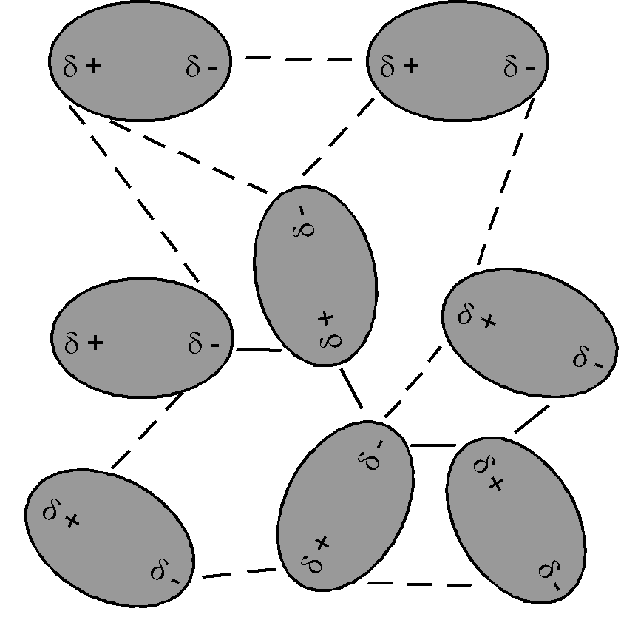

London Dispersion Forces

These are small electrostatic forces that are caused by movement of electrons within the covalent bonds of molecules that would otherwise have no permanent dipole. As one molecule approaches another the electrons of one or both are temporarily displaced owing to their mutual repulsion. This movement causes small, temporary dipoles to be set up which attract one another. These attractions are called London Dispersion Forces.

These dispersion forces increase with the size of the molecule and with its surface area. Large molecules with big surface areas have more electrons, and more dispersion forces and greater attraction and therefore higher boiling points.
- Other aspects of bonding theory

The solid state

Variations in bond type lead to different structures in solids. In this section we will discuss four different types of structure and the properties of such structures.

A: Giant atomic structures. E.g. Diamond and graphite.

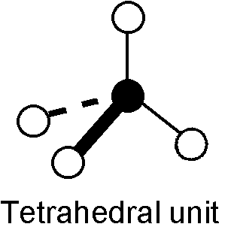
These structures are made of carbon atoms covalently bonded together in a continuous network. The diamond structure is based upon the tetrahedral unit, graphite on a layered structure. All the covalent bonds in these structures are very strong leading to them having high melting and boiling points and them being hard solids.

COVALENT NETWORK SOLID:
Network of bonds that link every atom in the solid to every other atom
Gigantic molecules
Hard, nonvolatile
Very high melting point
Insoluble in both water and organic solvents
Do not conduct electricity
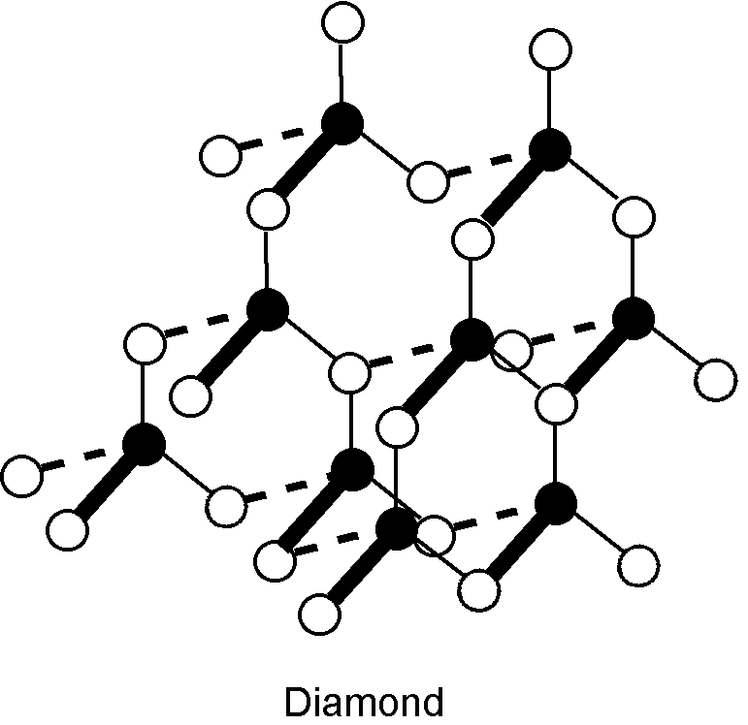
Made of carbon
One of the hardest known materials
Gemstone, cutting tool
Tight Bonds

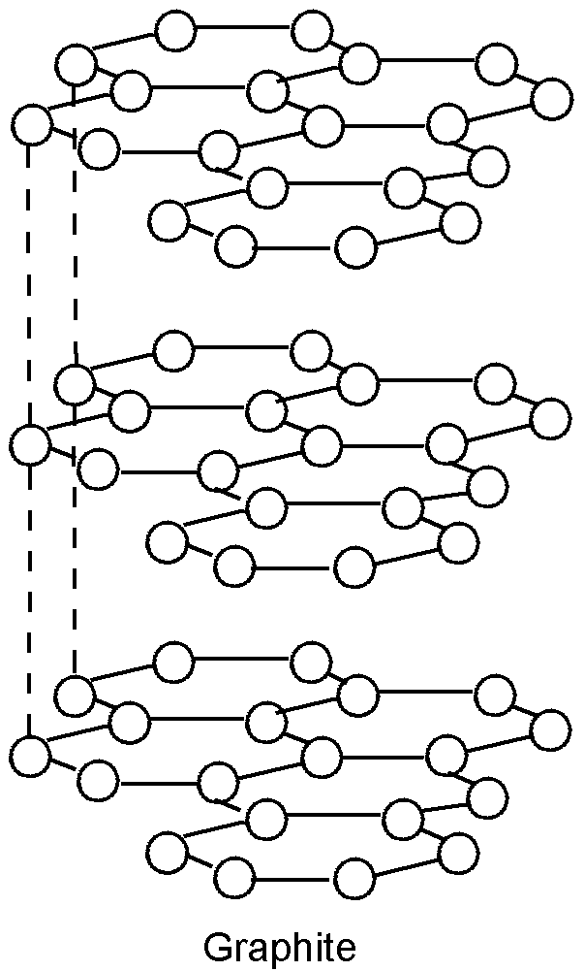
Made of carbon
Soft, slippery material
Weak forces

Graphite has two specific properties that are worth noting;

(i) It will conduct electricity only in one plane.

In the graphite structure each carbon is only bonded to three others. This leaves one of the outer electrons "free". Each carbon atom has one such "free" electron and these are spread out over each layer (delocalized). This leads to a "sea" of electrons similar to that in the metallic structure and graphite's ability to conduct electricity along the layers. Since the electrons cannot move between layers there is no conduction in the vertical plane.

- It can be used as a lubricant.

Weak dispersion forces hold the layers in graphite together represented by the dotted lines on the diagram. As a result they can slide over one another, this making graphite a good lubricant.

B: Molecular structures. E.g. Iodine

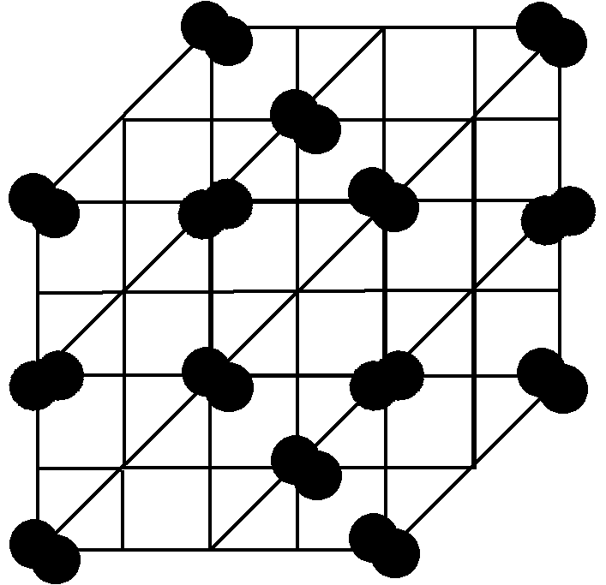

Iodine is held in a similar lattice structure to NaCl but in this case only weak dispersion forces hold the I₂ molecules in place. This means that solid iodine has a very low melting point since there is only a weak interaction between its molecules. In addition there are no charged particles present making iodine a non-conductor.

General Characteristics of covalent compounds:

Made of molecules

Soft, easily melted, and volatile
Insoluble in water
Soluble in organic solvents
Low melting point

C: Ionic structures. E.g. Sodium chloride.

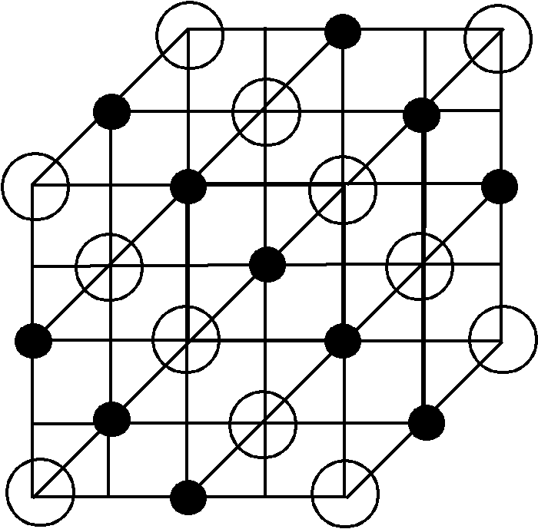

In the ionic structure the lattice of ions is held together by strong electrostatic interactions between them. The strong bonds give ionic solids high melting points. They can only conduct electricity when molten or in solution since in the solid the ions are rigidly held and cannot move.

General Characteristics of Ionic compounds:
Contain ions
High melting points

Soluble in water
Insoluble in organic solvents
Does not conduct electricity in solid sate
Conducts electricity in aqueous solutions and in pure molten form
Crystalline
Large lattice energies
Brittle
Lattice Energy:

It is generally recognized that the melting point of a substance is an indication of the strength of the bonds holding the atoms of an ionic substance together. The strength of the bond is determined by the radii and charges on the ions.

Coulomb’s Law is a fundamental relationship between charge and electrostatic force that allows us to predict the trend lattice energy.

q_{c}q_{a}
E = k
d

k = 8.99 x 10⁹ J-m/C²

Explain why the melting point of NaI is lower than NaF.

NaF
990°C

NaI
660°C

Explain why calcium chloride has a higher melting point than potassium chloride
(m_{pCa} = 772°C; m_{pK} = 770°C)

Hydration of ions and the solubility of ionic compounds

The charged particles present in an ionic solid explain how and why ionic solids dissolve in water. When an ionic solid dissolves the polar water molecules penetrate the lattice and attach themselves to the ions. The process is called hydration and the ions are said to be hydrated.

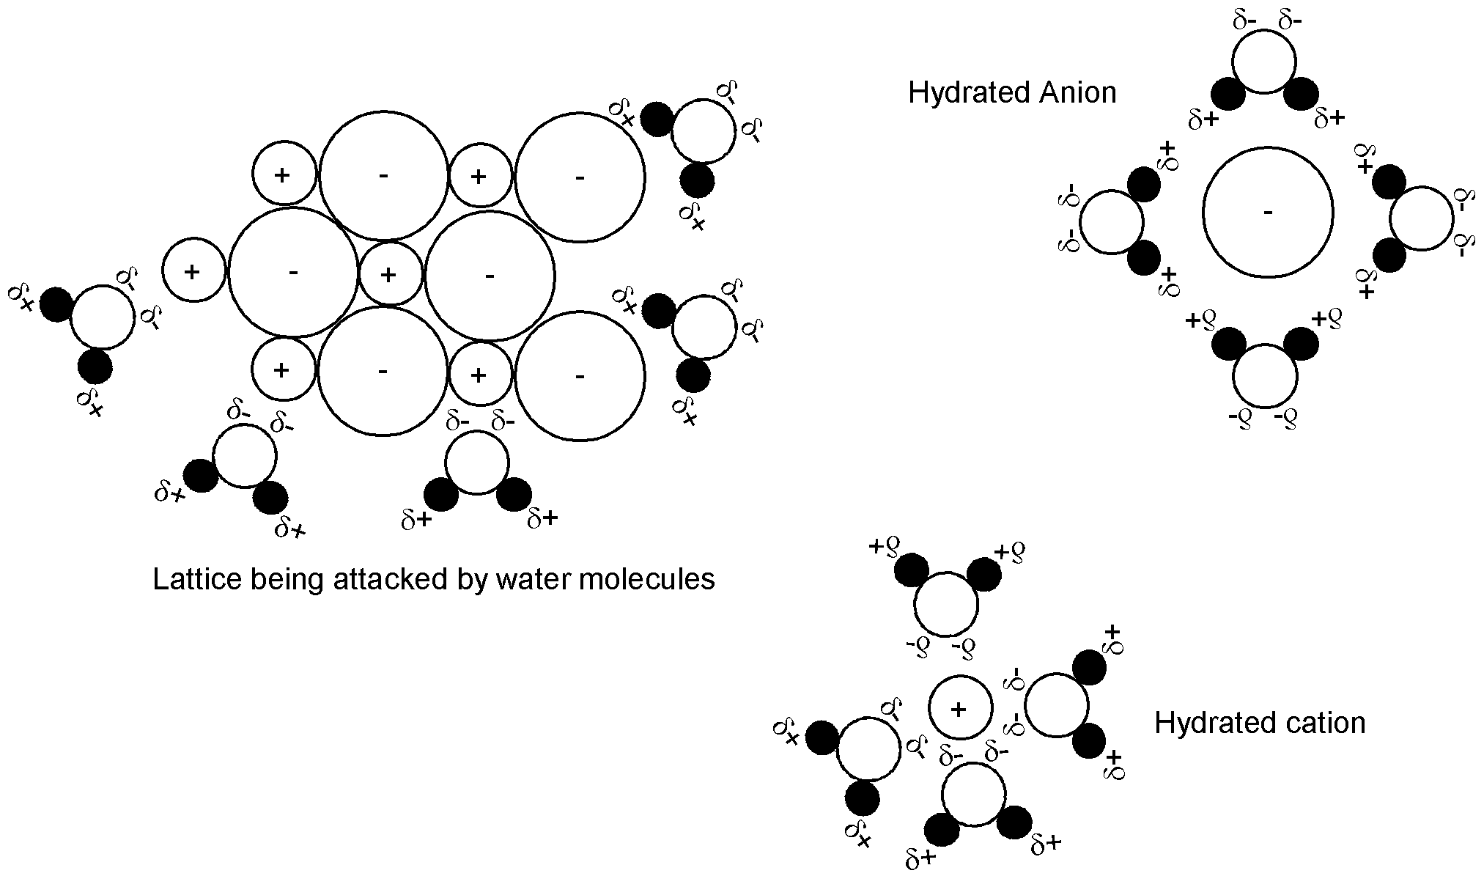

D: METALLIC BONDING (the structure of metals)

A metals' structure can be considered to be a close packed lattice of positive ions surrounded by a "sea" of electrons. These electrons and their movement cause metals to be good conductors of electricity. The close packed ions make them good conductors of heat.
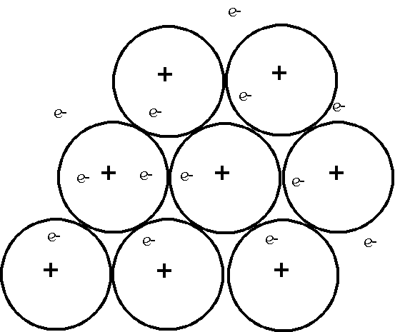
Metallic Solids:

Metallic bonds, strong non-localized bonds
High melting point
Hard, ductile, malleable, nonvolatile, and shiny
Some dissolve by reacting with water
Some dissolve in liquid Hg (amalgam)

The metallic bond is the electrostatic attraction between the positive and negative charges. The flexibility of these bonds makes metals malleable & ductile.

Explain why calcium has a higher melting point than potassium.
(m_{pCa} = 842°C; m_{pK} = 63°C)

The melting points of the alkali metals decrease as you go down the family. Why?

The ability to conduct both heat and electricity increase from sodium to aluminum. Explain the trend.

The liquid state

In a gas the molecules possess enough energy to overcome the intermolecular forces, and hence move around freely. When a gas is cooled the kinetic energy of its molecules falls and the intermolecular forces become increasingly important. Cooling eventually leads to them having insufficient energy to overcome these forces and the gas condenses to form a liquid.

In a solid the particles have a regular ordered structure and move very little around fixed positions. As solids are heated the particles gain energy and can break away from this ordered arrangement forming a liquid.

The liquid represents the molecules at an intermediate state between the ordered state of the solid and the disordered state of the gas.

Vapor pressure

Consider a liquid in a sealed container. Even if the liquid is below it’s boiling point a few of the molecules will possess enough energy to overcome the intermolecular forces holding them together and escape into the vapor phase above the liquid. The weaker the intermolecular forces between the molecules, the easier this process will be and the more molecules will enter the vapor phase. This causes a relatively high vapor pressure. So, in summary, weak inter molecular forces cause liquids to have low boiling points, they are said to be volatile and will have high vapor pressures, and visa-versa.

The gaseous state

Boiling points of the Noble gases

On descending group VIIIA the atomic number increases, the atoms get bigger, have more electrons and larger surface areas. This increases the dispersion forces between them making them more difficult to separate and increasing their boiling point.

Element | He | Ne | Ar | Kr | Xe
Boiling Point / ºC | -269 | -246 | -186 | -152 | -108

Boiling points of the Hydrides of Groups IVA, VA, VIA and VIIA

Group IVA Hydride | CH₄ | SiH₄ | GeH₄
Boiling Point / ºC | -161 | -112 | -90

The boiling point increases due to increased size and dispersion forces.

Group VA Hydride | NH₃ | PH₃ | AsH₃ | SbH₃
Boiling Point / ºC | -33 | -87 | -60 | -25

A similar pattern (of increase of size, dispersion forces and boiling points) is observed here except for ammonia. The ammonia molecules are attracted to one another by hydrogen bonds giving ammonia a higher boiling point than would normally be expected.

Group VIA Hydride | H₂O | H₂S | H₂Se | H₂Te
Boiling Point / ºC | 100 | -65 | -45 | -15

Group VIIA Hydride | HF | HCl | HBr | HI
Boiling Point / ºC | 20 | -85 | -69 | -35

The patterns in groups VIA and VIIA resemble that of group IVA with water and hydrogen fluoride respectively exhibiting the higher boiling points associated with hydrogen bonding.

Polyatomic molecules and hybridization of orbitals

When considering a polyatomic molecule the question of shape must be accounted for. Valence bond theory incorporates shape by assuming the hybridization (mixing) of outer (valence) shell orbitals. Consider the example in the table below of the sp³ hybridization of carbon in the methane (CH₄) molecule.

In its ground state the carbon atom has two unpaired electrons and as such it may only make two bonds with hydrogen atoms to form the species CH₂. However this species is extremely unstable and does not exist. In order to form the much more stable CH₄ molecule (that does exist) one of the electrons in the 2s orbital is promoted into the empty 2pz orbital to form the excited state of [He] 2s¹ 2px¹ 2py¹ 2pz¹. These four orbitals then mix together to form the four-sp3 hybrid equivalent orbitals. These four hybrid orbitals then form simple sigma bonds with each of four hydrogen atoms to give four electrons pairs around the central carbon atom thus forming the familiar tetrahedral shape.

In all of the examples below the terminal atoms join the central atoms hybridized orbitals using simple sigma bonds to form the final molecule. There are more complicated hybridization patterns involving pi bonds for polyatomic molecules that form multiple (double and triple bonds) that are not considered here.

